**LAB 1:**

**1. What is ORM?**

**ORM (Object-Relational Mapping)**

ORM is a programming technique that lets you interact with a relational database (like SQL Server) using object-oriented code.

**2.**

| **Feature** | **EF Core** | **EF Framework (EF6)** |
| --- | --- | --- |
| Platform | Cross-platform (Windows, Linux) | Windows-only |
| Performance | Lightweight & faster | Heavier |
| LINQ & Async Support | Full | Partial |
| Mapping to JSON Columns | Supported (EF Core 8.0) | Not supported |
| Maturity | Newer | Mature, stable |
| Recommended for new apps? | Yes | No |

**3. EF Core 8.0 Key Features**

* **JSON Column Mapping:** Map nested data directly to JSON columns
* **Compiled Models:** Faster startup and query execution
* **Interceptors:** Hook into lifecycle events like SaveChanges
* **Improved Bulk Operations:** Efficient AddRange, UpdateRange, etc.

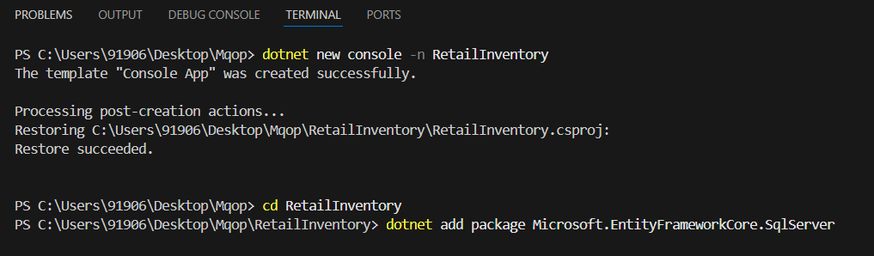

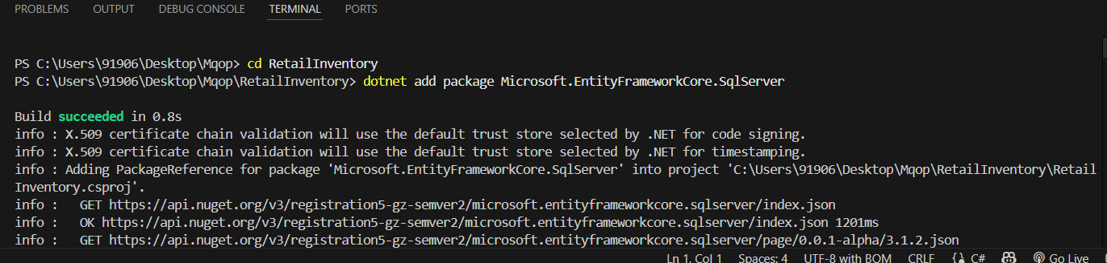

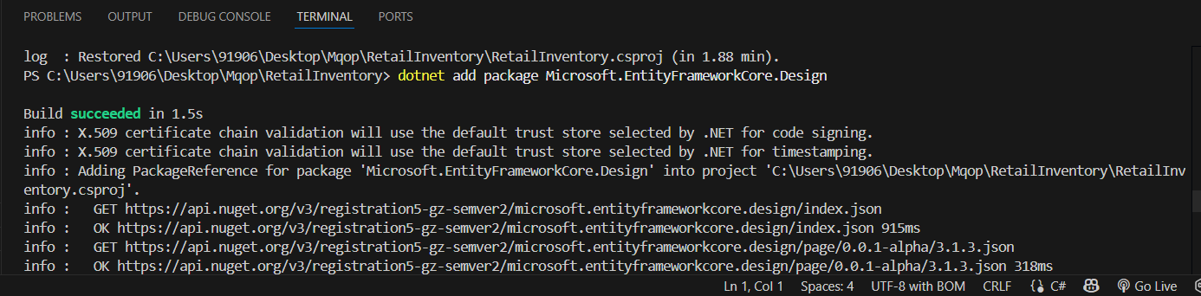

**LAB 2:**

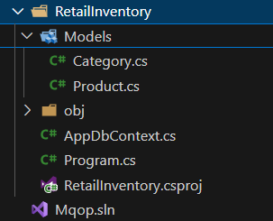

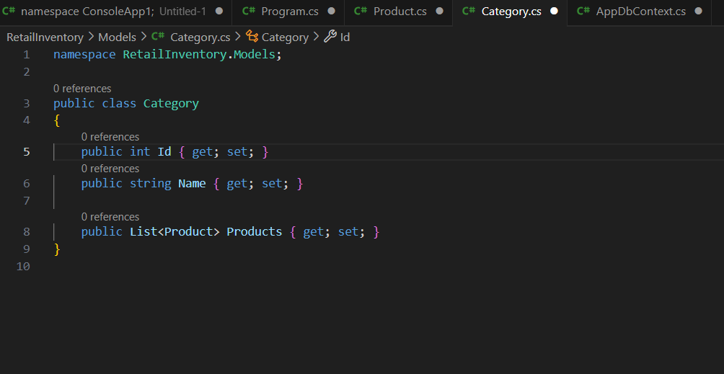

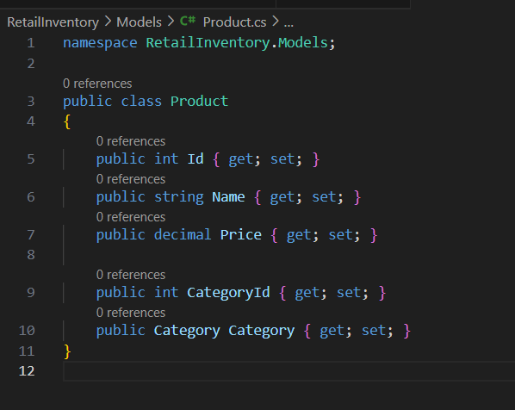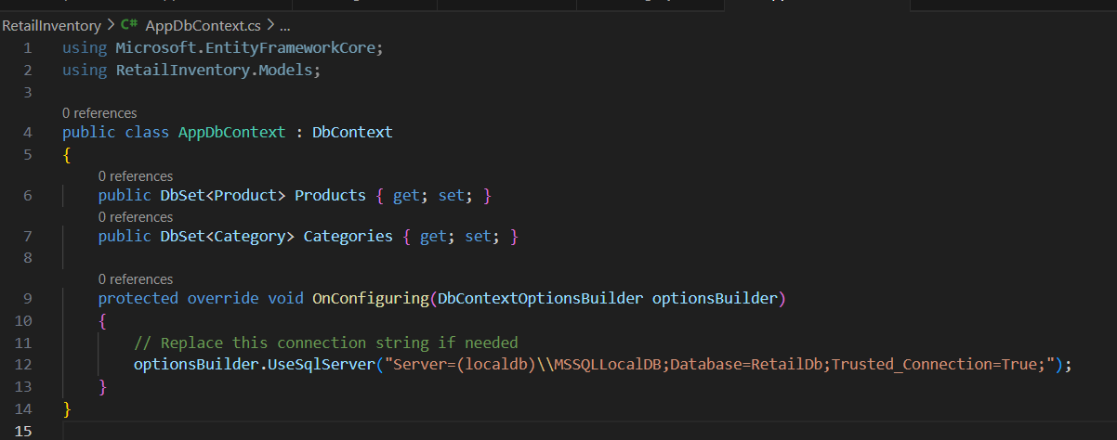

**LAB 3:**

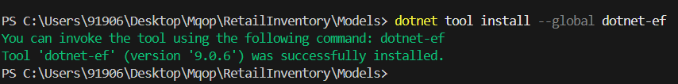

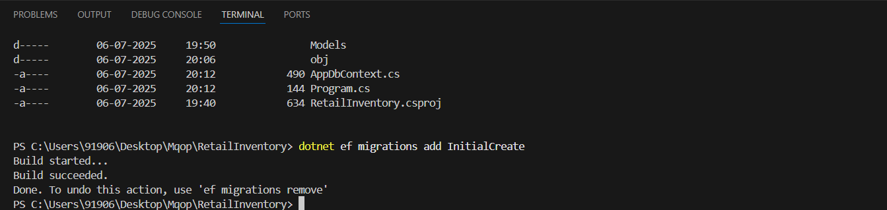

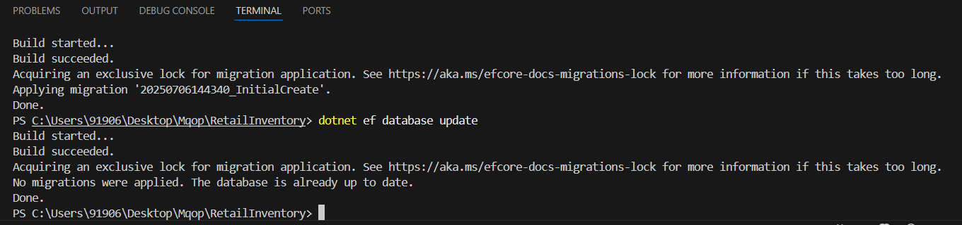

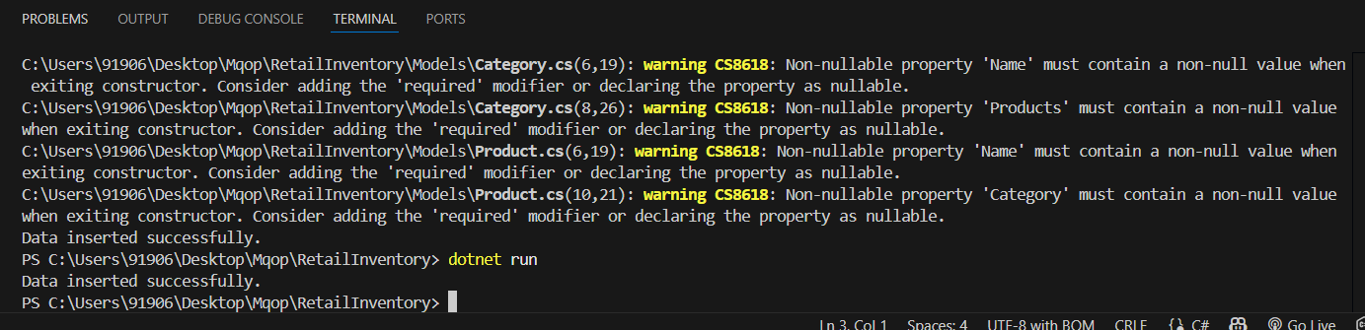

**LAB4:**



**Lab5:**

